SOMERSET COUNTY COUNCIL MUSIC HUB STRUCTURE
APPENDIX 2
ACE

Commissioning Arm
Traded Arm
Director of Children’s Services
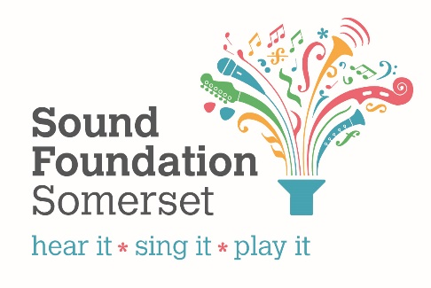
Strategic Manager – Support for Educational Improvement
Head of Support Services for Education (SSE)
Independent Chair of MEH Management Board (Voluntary)
Schools Officer: SMEP & Curriculum Planning/Support
(0.6 FTE)
Head of Educational Outcomes and Sufficiency
Instrument Technician (0.6 FTE)
Teaching Staff (various hours)
Business & Commercial Support Officer Business &
(0.8 FTE)
Senior Business Support Assistant
(0.4 FTE)
Area Music Advocates/Champions (Voluntary)
Quality Assurance Consultant
Deputy Director
(1.0 FTE)
Deputy Director
(0.6 FTE)
Main External Delivery Partner Organisations
Take Art (NPO) (Early Years)
Director of
Somerset Music
(1.0 FTE)
Jackdaws Music Education Trust
Taunton Music Trust (Singingworx)
Bournemouth Symphony Orchestra (BSO)
SPAEDA
South West Music School
Actiontrack Performance Company
Centre for Young Musicians (CYM)
Business & Commercial Support Assistant (1.0 FTE)
Music Hub Lead
Music & Arts Executive Officer (0.8 FTE)

