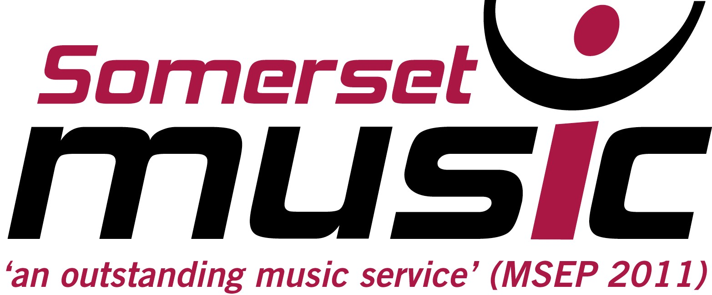


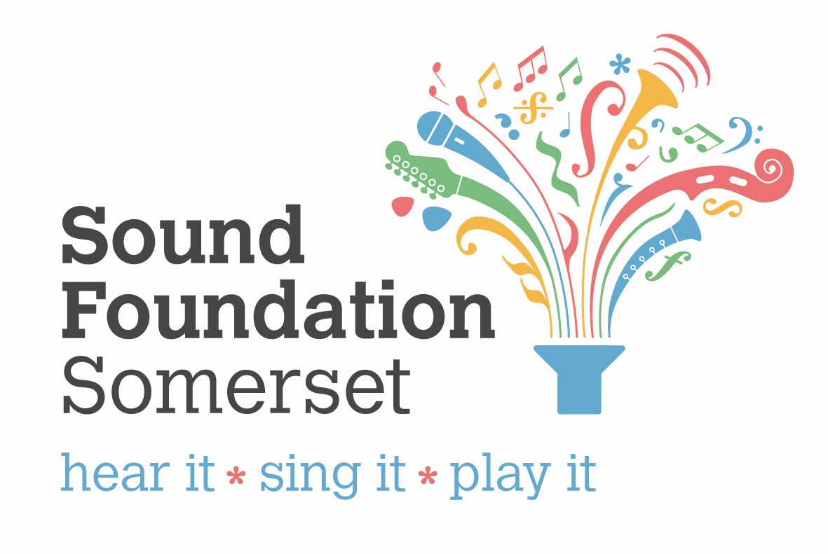

Primary Music Conference

‘Sing Yourself Happy’

A full day of practical sessions, directly transferable to the classroom.

Friday 17th May, Dillington House, Ilminster

£50 per delegate (lunch included)

Session 1 11.30-12.30 | Session 2 1.30 – 2.30 | Session 3 2.50 – 3.50
Teach the Music Curriculum through song  Charlotte Law - Sing Up  KS 1 & 2 | Improve your school choir  Charlotte Law - Sing Up  KS1 & 2 | 'Music speaks louder than words - how to include children with Autism.'  Ruth Garbett  KS1 & 2
Delivering a successful music lesson; the logistics  Kirsten Wordley  KS 2 | Introduction to Charanga Musical School  Analie Hart - Charanga  New users | Charanga Musical School for ADVANCED users  Analie Hart - Charanga  Advanced users
Improvisation workshop  Chris Large  KS1 & 2 | Rocktopus - Rock the Sport  An interactive Songwriting & PE workshop  Rocktopus  KS1 & KS2 | Rocktopus - Rock the Sport  An interactive Songwriting & PE workshop  Rocktopus  KS1 & KS2
Musical fun with Boomwhackers – KS1  Nicola Thompson  KS1 | Writing a Music policy  Nicola Thompson  KS 1 & 2 | Musical fun with Boomwhackers – KS2  Nicola Thompson  KS2

